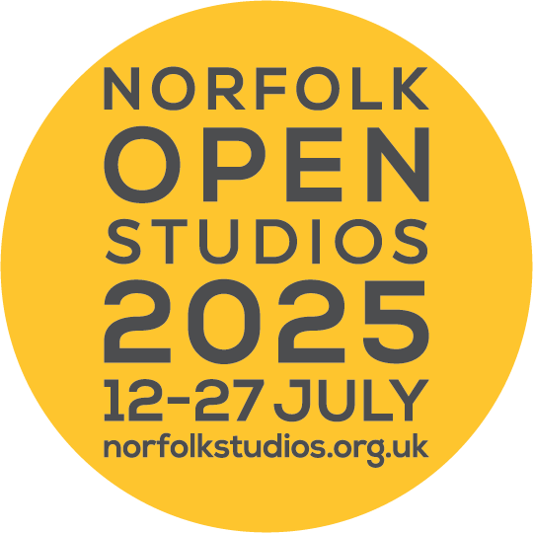

**School Application Norfolk Open Studios 2025 (NOS 2025)**

The following information you provide will be included in your school’s listing and published in the brochure and on the Norfolk Open Studios website.

For questions that do not require a written answer, please use a tick or write the word ‘yes’ or ‘no’ in the relevant box.

**Please complete clearly in type or dark ink in the grey shaded areas only.**

**Section A: School details**

|  |  |
| --- | --- |
| Name of school |  |
| Address of school in full (inc. postcode) |  |
| Phone number of school |  |
| Local Authority Area of your school (i.e. Breckland, Broadland, Great Yarmouth, North Norfolk, Norwich, South Norfolk or West Norfolk |  |

**Section B: Lead contact person details**

(for office correspondence only and will not be published)

|  |  |
| --- | --- |
| Name of lead contact person  (for NOS Schools participation) |  |
| Telephone / mobile number (preferred) for lead contact person |  |
| Email address for lead contact (most of our communication with you will be via email) |  |

**Section C: Visitor access**

|  |  |  |
| --- | --- | --- |
| **Statement** | **Wheelchair symbol** | **Yes / No** |
| Is your school *fully* accessible by wheelchair users? (See description below) | Green |  |
| If you have answered no, is your school on the ground floor & does it have wide enough doors? (See description below). Visitors can ring ahead to discuss access arrangements with you. | Amber |  |
| If you have answered no to both questions above, please be prepared for some visitors to phone ahead to discuss access possibilities with you. | Red |  |

For your school to be **fully** accessible by wheelchair users it will need to have parking spaces at least 3.6 metres wide, doors at least 0.75 metres wide and a level entrance (with no steps or thresholds greater than 20mm high).

|  |
| --- |
| Are there other visitor access issues worth noting? If yes, please describe below, e.g. difficult terrain, distance from car park to studio/exhibition space, steps etc. |
|  |

**Section D: Studio / Exhibition details**

|  |  |
| --- | --- |
| Address of venue for exhibition  (if not at the school detailed in section A) |  |
| Venue phone number (if not at the school detailed in section A) |  |
| Opening dates of exhibition  (schools need to open for a minimum of one day or evening during NOS dates) |  |
| Special opening times (if not 10am - 5pm) |  |
| Brief description of exhibition  (30 words max and subject to editing. Include things such as; what will be exhibited, the mediums used, the general theme/topic of the work, the year group of pupils involved, etc) |  |

**Section F: Images**

Please submit image(s) with your application. One image will be used in your school’s listing in the printed brochure and up to four can be used on the website. Consider carefully what images you use. The image you choose for the brochure will be central to the promotion of your school’s Open Studio/Exhibition. We would like to see high resolution images of artwork produced by pupils, or images of pupils creating art.

By supplying these images you are confirming that they have the appropriate image permissions for publication in the NOS brochure and website.

Images need to be supplied as;

* a jpeg or tiff file
* at least 300dpi (dots per inch)
* a **minimum of 500KB** in file size and a **maximum of 3MB**

PLEASE NOTE: images larger than this may not reach our mailbox resulting in your application not being received. Images smaller than 500KB will not be of high enough quality when reproduced in the brochure.

Please label your images, clearly indicating which one you would like to include in the brochure. Include your school name and image title, and indicate which way round they should be used. Email to [openstudios@nnfestival.org.uk](mailto:openstudios@nnfestival.org.uk) with your school’s name in the email subject line and image titles in the body of the email (preferred method). Alternatively, you can submit image/s on CD.

Please give details below of the images submitted with this application.

|  |  |  |  |  |
| --- | --- | --- | --- | --- |
| **Image** | **Title/file name** | **Medium** | **Disc enclosed**  (if applicable) | **Emailed**  (if applicable & include date emailed) |
| 1 *(for use in the brochure)* |  |  |  |  |
| 2 |  |  |  |  |
| 3 |  |  |  |  |
| 4 |  |  |  |  |

**Section G: Payment details**

Fee per school: £200.00 (inc. VAT)

You can pay by BACs, card or cheque or via our [secure online payment system](https://norfolkstudios.org.uk/memberships/). If paying by cheque, please make cheques payable to ‘Norfolk & Norwich Festival Trust’.

For BACS payment, see details below;

**Account**: Norfolk & Norwich Festival Trust

**Sort Code**: 20-62-53

**Account no**: 20662984

**Reference to include (if possible)**: NOS/school name or school initials

*Please complete the below to ensure that we are able to identify your BACS payment.*

|  |  |
| --- | --- |
| Name of payee as it will appear on our BACS statement |  |
| Date of payment: |  |

To pay by card please call 01603 877762 with your card details (Tuesday to Thursday, 10am – 5pm).

**Section H: Confirmation of NOS schools agreement**

Please sign or type your name in the box below to confirm that you have read and are in agreement with the [terms and conditions for schools](https://norfolkstudios.org.uk/terms-conditions-for-schools/).

|  |  |
| --- | --- |
| **Data Protection Act 1998**  The information that you provide on this form will be handled and stored in accordance with current Data Protection legislation. By submitting an application for the Norfolk Open Studios Schools scheme you are consenting to the recording and use of the information which you supply. | |
| Signature (type your name if completing electronically) |  |
| Full name |  |
| Date |  |

**The deadline for registrations is Sunday 2nd March.** Please return your completed application form, images and payment using one of the following methods:

By email: [openstudios@nnfestival.org.uk](mailto:openstudios@nnfestival.org.uk)

By post: Norfolk Open Studios 2025

Norfolk & Norwich Festival

Norwich Guildhall

Gaol Hill

Norwich

NR2 1JS

You will receive an email from the NOS Office to confirm receipt of your application by Friday 7th March. If you have not heard from us by this date, please get in touch to check it’s been received.